AERONAUTICAL COMMUNICATIONS PANEL (ACP)

WORKING GROUP C – 6th Meeting
Toulouse France
20-24 October 2003

Agenda Item 6: Evaluation of Potential Technologies

Information Paper on 8.33 Climax Operations
in
UK, Germany and the rest of Europe

Prepared by:
Mr. J. J. MacBride
NATS Ltd (UK)

SUMMARY

This information paper explores the operation of Air Traffic Control (ATC) Air-Ground (AG) communications channel using 8.33 Climax (8.33C).

The paper starts with a résumé of the current Climax operations based on the current 25kHz system, then looks at the technical basis and benefits of 8.33 ‘off-set’ operation.

Multicarrier/Offset Carrier/Climax Operations

Climax Operations refers to an Air-Ground communications channel broadcasting simultaneously via two or more transmitters, as shown below:

To prevent the degradation in audio quality caused by hetrodynes, the transmitter station’s broadcast frequency is offset by a fixed amount from the channel centre frequency. The operation is commonly referred to as offset carrier or climax operations and is detailed in Annex 10, as shown below:
Figure 1: Configuration of a Two-Leg Climax Channel

No of Climax Leg | Leg 1 Tx frequency | Leg 2 Tx Frequency | Leg 3 Tx Frequency | Leg 4 Tx Frequency | Leg 5 Tx Frequency
2 | f_{c} + 5 kHz | f_{c} – 5 kHz | N/A | N/A | N/A
3 | f_{c} + 7.5 kHz | f_{c} | f_{c} – 7.5kHz | N/A | N/A
4 | f_{c} + 7.5 kHz | f_{c} – 7.5kHz | f_{c} +2.5kHz | f_{c} -2.5kHz | N/A
5 | f_{c} -2.5 kHz | f_{c} – 7.5kHz | f_{c} -2.5kHz | f_{c} +2.5kHz | f_{c} + 7.5 kHz
Table 1 Frequency arrangements for climax channels (f_{c} is the assigned channel frequency)

The offset values are based on the principle of reducing (or preventing) heterodynes from being generated within the audio band, which would dramatically degrade speech intelligibility.

8.33kHz Climax
Figure 2 Proposed 2-leg 8.33kHz Climax Operations Scheme
For an 8.33kHz Channel, the current recommendation is that the channel will broadcast using one transmitter at any one instance. Climax Operation of
8.33kHz channel was initially believed to be unfeasible. This was due to the fact that the bandwidth requirements extend beyond a typical 8.33kHz envelope. It was also believed that the overlapping of sidebands might degrade the demodulated signal to an intolerable extent.

The DFS and NATS have commenced a programme of study to verify the feasibility of utilising 8.33 Climax (8.33C) Operations in terms of audio quality, ground and avionics radios adjustments, frequency planning, Minimum Operating Specifications amendments (MOPS) and institutional issues.

The initial research concentrates on optimising the offset, f_{o}, for the best audio quality in the overlapping or protruding sidebands as well as proving the effects of 8.33C to a combination of avionics transceivers. Scientific methods such as measuring speech quality using ITU standards have been used. Due to the narrower bandwidth of 8.33kHz channel compared with its 25kHz counterpart, only two-leg climax operation would be viable.

8.33kHz Climax – the benefits

There are various drivers for implementing an 8.33C system, as follows:

Extended Coverage

One of the issues surrounding the current 8.33kHz implementation is that, the coverage is limited to the coverage achieved by a single transmitter. For an 8.33kHz sector with terrain restriction, the coverage provided by the 8.33kHz single transmitter might be deemed inadequate. In some situations, there is a risk that the designated sector might not be adequately covered by one 8.33kHz transmitter site. The Central European Air Traffic Services (CEATS) member states have recently encountered this problem in their airspace design.

This argument is not exclusive to terrain limitations, it also applies to sectors that are designed to be laterally large, non-circular or operate at low levels. All these reduce the margins between the maximum range provided by the transmitter and the perimeter of the required coverage. For these situations, a mean to extend the coverage is required, hence the need of 8.33C operations.

8.33C operations has the capability of significantly increasing coverage for 8.33kHz channels, as below:

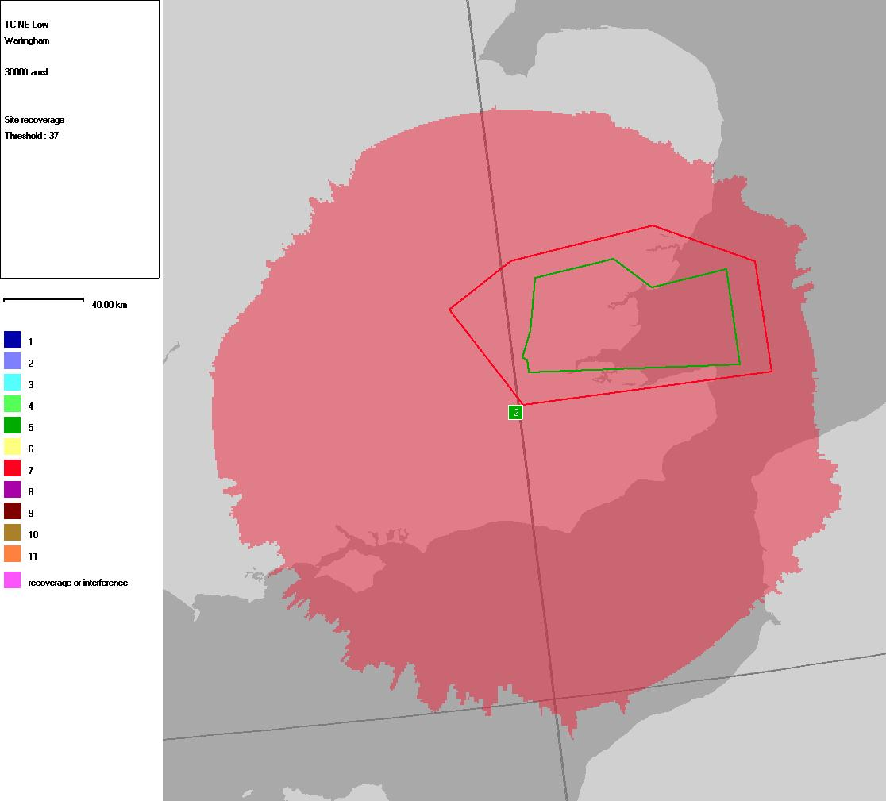
Proposed Sector
Figure 3 Coverage prediction (shaded in red) of a single transmitter station

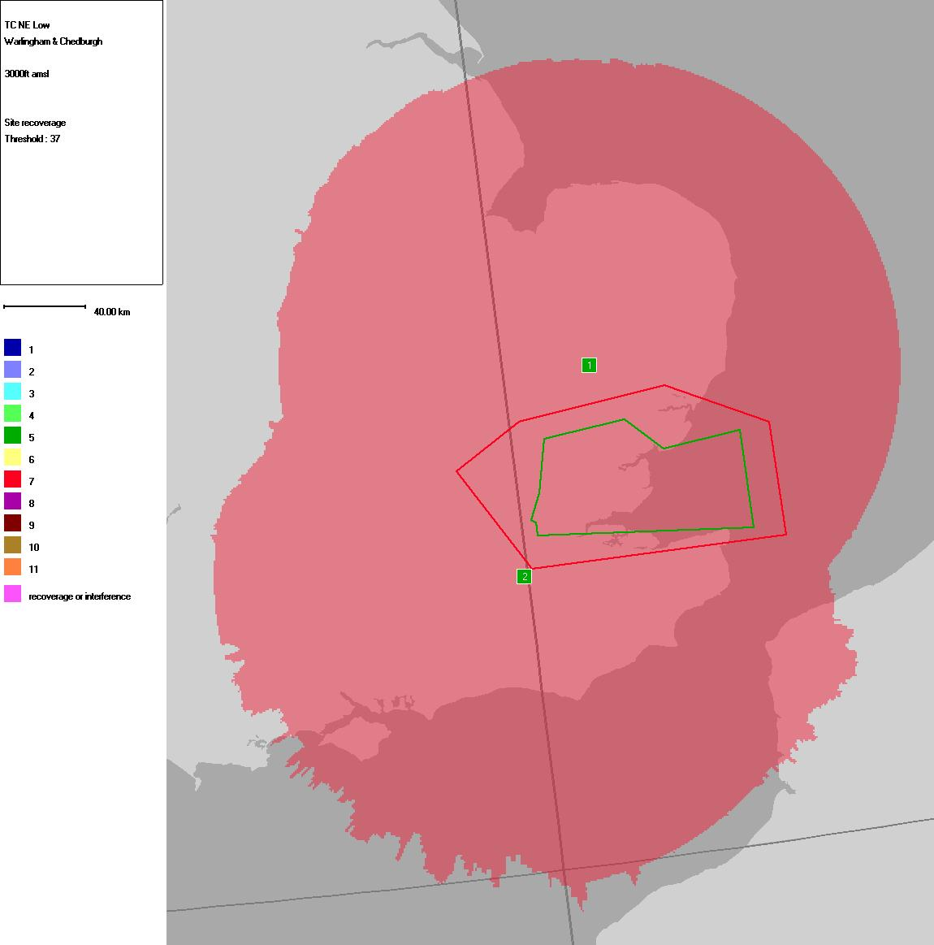
Proposed Sector
Figure 4 Coverage provided by 2-leg 8.33C Operations,

Reduced Frequency Congestion

Frequencies are at a premium, whether they are 8.33kHz or 25kHz spacing ideally therefore, the more conversion from 25kHz to 8.33kHz, the higher the savings in spectrum terms because each 8.33kHz occupies only one-third of the 25kHz bandwidth. For a number of reasons a ratio of 1:3 will not be realised in converting a 25kHz channel to 8.33kHz. However increased benefits will be seen when the number of 8.33kHz conversions increases across a large geographical area (in terms of regions, rather than individual countries).

Increased redundancy

In the UK, one of the reasons for using Climax operations is the increase in redundancy of the system. For airspace that has high safety requirements, e.g. Terminal control, Climax operations provides duplex coverage whereby loosing one transmitter station will not affect the coverage in the sector.

Costs

In the near to medium terms, 8.33C may be the only means of introducing more voice channels in the VHF band. The cost of introduction of VDL3 is estimated in the order of several tens of million of Euros.

For 8.33C, no changes are required for workstations and voice switches, only radio sites upgrades are required. The DFS estimated the cost of approximately 7.13 Million Euro to covert all their 25 x 25kHz Climax channels to 8.33C operations. The impact on avionics is to be confirmed but initial test results suggest that no major modifications are required for on-board avionics to operate in an 8.33C environment.

Technical Feasibility

Climax Operation – the European picture

Eurocontrol has recently researched on the usage of 25kHz Climax by their members’ states, as follows:

State | Number of climax sectors | Upper ACC | Reasons for Climax
Bulgaria | ACC= 7, APP= 2, VFR= 1, 30 stations | 7 (not a HEX state) | Terrain problems
Croatia | Under review | 3* | Large area of merged sectors and terrain configuration.
Czech Republic | FIC and VOLMET, 2 Stations | 0
Denmark* | ACC/U: 1 | 1*
Estonia | ACC Upper – 3 stations,  ACC low – 3 stations | 1 | ATCO convenience for large sectors; large numbers of low flying a/c; sea and lake.
Finland | None. | 0
Germany |  | 25
Hungary | None. | 0
Italy |  | 13* | Large coverage areas, availability and terrain.
Ireland | None. | 0
Lithuania | None | 0
Norway | New equipment being installed in late 2001:ENSV-South: 3 stations;  ENSV-North: 3 stations;  ENSV-West: 2(3) stations; 3 other offshore sectors possible at later date. | 3-5 | Large, high-level sectors with low –level  Traffic. Reduction in controller workload. Potential landline problems at remote transmitting site.
Poland | All 6 ACC sectors are using CLIMAX.GRU, SUW, DRE, JED,TRZ - 3 stations LDZ - 2 stations | 6 | - Large coverage area  - Landline availability
Portugal | 4 North, Centre, South, Demos Veran | 4 | Large sectors, landline availability, terrain problems.
Romania* | Yes | 7*
Slovakia | 2 sectors: FIC for VFR flights; second is military sector; both operating from 4 sites. | 0 | Terrain problems.
Slovenia | One APP sector, 2 stations. | 0 | R/T coverage at low levels.
Spain | FIR Madrid: 10 sectors each with 2 stations; FIR Barcelona: 3 sectors each with 2 stations. | 13 | Large sectors
UK | Terminal Control  Area Control | 202 | Redundancy  Coverage  Safety
Summary |  | 280+ | Excluding Bulgaria
Table 2 European Usage of Climax in Europe
Notes:
- *- Did not respond to latest questionnaire - information derived from 1999 questionnaire.

Some of the countries above have plans to transition to 8.33 operations. Instead of Climax systems, they are considering using a variety of methodologies to increase coverage, such as Best Signal Selects (BSS) transmitters.

Finding 8.33kHz Candidates

For the UK, one of the critical factors in determining whether the existing 25kHz channels can be converted to 8.33kHz operations, as well as introducing 8.33C for them (if appropriate), are the minimum flight levels the sectors are operating. Only sectors with the minimum operating level of FL245 can be considered as 8.33kHz candidates currently. There are 11 of them identified currently.

If the minimum level of operations is reduced to FL195, the number of candidate channel, using single transmitter operation, will be reduced to 8 (based on the original 11), this reduction is due to the lack of coverage provided by a single transmitter.

If the minimum flight level were further reduced to FL150, only one candidate channel would qualify (based on the original 11) due to limitation of single transmitter coverage. Hence, the importance of 8.33C Operations is apparent.

8.33 Climax Convertibility

The DFS has performed engineering feasibility analysis into conversion from 25kHz Climax to 8.33C operations, subject to research and development work proving the technical feasibility of 8.33C and ATC operations approvals, all (25) of the current 25kHz channels can be converted to 8.33 Climax. This echoes NATS view that most of its 2-leg 25kHz channels (approximately 30) can be converted to 8.33C operations provided the sector minima does not infringe the 8.33kHz minimum flight level operations requirements.

Interpolating this argument to Europe, this would also apply to most of the channels in Table 2. As an estimate, using 15% (NATS apportionment) of the 2–leg channels Europe-wide, the minimum number of channel that could be transferred is 42. That will refer to a net release of 126 new 8.33kHz channels available for use regionally.

Conclusions

This information paper has detailed the technical basis of 8.33 Climax operations. Some potential benefits for the UK, Germany and Europe for having 8.33 Climax as an available technology have been identified, as follows:

- Offers extended coverage
- Should alleviate frequency congestion problems
- Increases redundancy
- At minimum costs

Recommendations
In view of the potential benefits of 8.33 Climax operations this meeitng is invited to :-

- Note that 8.33kHz ‘offset’ is potential a technology that could help to alleviate spectrum requirements and

- recommended that further work is performed to verify the technical, operational and institutional feasibility of this technology.

Results of the 8.33C research conducted by the DFS and NATS Ltd carried out by the DFS and NATS Ltd.
In the UK, the area which require coverage for a particular sector is known as the Operational Coverage Requirements (OCR)
Source, DFS September 2003
Source: Eurcontrol September, 2003
This figure is for reference only, subject to airspace redevelopment that takes place frequently
This is part of the proposal from Eurocontrol’s 8.33kHz Vertical Expansion (VEX) programme

